

Final Year Project Report

**PakWork**

Project Team:

Asaad Noman Abbasi (1912297)

Muhmmad Ahsan (1912310)

Project Supervisor:

Muhmmad Shahzad Haroon

Date: 9th November 2022

Submitted in partial fulfillment of the requirements for the degree of

Bachelor of Science in Computer Science

in the

Faculty of Computing and Engineering Sciences

Shaheed Zulfikar Ali Bhutto Institute of Science and Technology

(SZABIST)

Karachi Campus

**Declaration of Authorship**

We, Asaad Noman (1912297) and Muhammad Ahsan (1912310), declare that this report titled, “PakWork” and the work presented in it are our own. We confirm that: This work was done wholly or mainly while in candidature for a bachelor’s degree at this University. Where any part of this report has previously been submitted for a degree or any other qualification at this University or any other institution, this has been clearly stated. Where we have consulted the published work of others, this is always clearly attributed. Where we have quoted from the work of others, the source is always given. With the exception of such quotations, this report is entirely our own work. We have acknowledged all main sources of help. Where the report is based on work done by us jointly with others, we have made clear exactly what was done by others and what we have contributed ourselves.

Signed: Asaad Noman (1912297), Muhammad Ahsan (1912310)

Date: 9th November, 2022

**Acknowledgment**

In the name of ALLAH, the most beneficent and merciful who gave us the knowledge and courage to work on this research area. The success and final outcome of this project required a lot of guidance and assistance from many people and we are extremely privileged to have got this all along the completion of our project. We would first like to thank our supervisor “Sir Shahzad Haroon” of the Computer Science faculty at Shaheed Zulfiqar Ali Bhutto Institute of Science and Technology. The door to his office was always open whenever we ran into a trouble spot or had a question about our project or documentation. He consistently helped, cooperated and motivated us throughout the research. We would like to thank to our teachers who guided us in the light of their knowledge and experience. We would also like to express our gratitude to our loving parents and family members who helped and gave us encouragement. Furthermore, we would also like to acknowledge with much appreciation the crucial role of the staff of SZABIST, who gave the permission to use all required equipment and the necessary materials to complete the project. At the end, we would like to thank Shaheed Zulfiqar Ali Bhutto Institute of Science and Technology for providing us such an inspiring environment. The quality education, the cooperative faculty members and the challenging environment have always motivated and boosted the confidence level of each and every student who has been a part of Shaheed Zulfiqar Ali Bhutto Institute of Science and Technology. And many thanks to all those who let us share their knowledge and resources.

# FYP Project Proposal

# Introduction

A Freelancing platform for freelancers. Where freelancers can easily sell their gigs and offer services to potential clients/businesses. We aim to provide a fully featured platform that provides everything necessary for a seamless process of a transaction between two entities.

# Objective

“*To design a platform for freelancers to provide their services to clients*".

# Problem Description

Nowadays, Working remotely seems to be on a much larger scale as many companies whether it be local or offshore are shifting to either hybrid or completely remote-based office environments. This also relates to freelancers, who work remotely with these companies and have tended to rise their numbers. In 2022 it was estimated that 70.4 million freelancers were working around the globe remotely. If we talk about Pakistan, it saw a rise of 48% in the year 2021-2022, ranking it as the 4th most popular country in the freelancing industry globally. There are quite a few benefits of freelancing, such as international remittance coming into local banks via platforms, and the creation of micro-agencies that grow into proper software houses which provide employment opportunities and thus upbringing society. For buyers, it also provides quick and efficient solutions to their problems.

Pakistani freelancers face quite numerous challenges when it comes to freelancing on international platforms, the most common challenge they face is such platforms that provide these services charge quite a handful of service charges for this. Another issue that is often raised by experienced professional freelancers is that clients come with projects that were either unfinished or ruined by unskilled freelancers. Also, the problem of unverified users is on the rise, as on platforms such as Fiverr a single user can create multiple accounts and work, no such identity checks are put into place. Which can lead to fake personas conducting business on the platform. Another issue faced by freelancers is the order policy. Due to some policies regarding order acceptance freelancers face unjustified disputes.

# Methodology

Now to address the ‘*How*’ part of the proposal. To tackle the challenges mentioned above, we aim to create a platform that targets freelancers with much easier policies and regional service charges. On the other hand, to tackle the issue of unprofessional and unskilled freelancers, we aim to provide a customized filtering process to ensure that only professional and skilled freelancers can be allowed to work on the platform. We also provide a customized test related to the job that is being bided by freelancers so that only matched freelancers can bid on outsourced projects by businesses, as this way we can tackle much of the filtering part we can offer to the clients. To tackle the issue of the order policy we will make sure that the freelancer has the choice to accept or decline customer job offers made by the client.

# Project Scope

In the previous para, we talked about all the aspects of the scope of the project we are going to develop and work on. But the scope for this project is much more and some development/design aspects will not be implemented in this due course. Such as

* We are not going to implement a payment holding system. Which is a common feature used by these platforms to cater order claims/disputes.

# Feasibility Study

**Risks Involved**:

* Unverified Freelancer using the platform

To tackle this problem, we will implement a system for the verification of CNIC / other documents for the freelancer

**Resource Requirements**: Cloud databases, Cloud service providers, Hosting servers

# Solution Application Areas

In today’s world, freelancing and remote work is on the rise. Pakistan is one of the top 4 service providers in the industry. Our platform aims to cater to the market of freelancers to connect them to potential international/local clients. International platforms charge hefty service charges. The money they make on the platform they withdraw to their local accounts. They are left with 75% of the money that they potentially make. Our platform aims to provide all the features that a competitive platform offers but with policies, service charges, and features to cater to the regional market.

# Tools/Technology

**Software Tools**

* Visual Studio Code
* GitHub Desktop
* NPM
* MongoDB Compass
* Postman / Thunderclient
* Photoshop
* AdobeXD

**Hardware Tools**

* Laptop / PC
* Internet / WiFi Connection

**Technologies**

* JavaScript
* jQuery
* Node JS
* Express JS
* React JS
* MongoDB
* Firebase
* MySQL
* Socket.IO

# Expertise of the Team Members

**Asaad Noman Abbasi (1912297)**

* **Courses Taken:** Fundamentals of Programming (4 GPA), Object Oriented Programming (4 GPA), Data Structures & Algorithms (3.25 GPA), Database Systems (4 GPA), Software Engineering (3.5 GPA), Web Technologies I (4 GPA), Design & Analysis of Algorithms (3.5 GPA)

**Muhmmad Ahsan (1912310)**

* **Courses Taken:** Fundamentals of Programming (4 GPA), Object Oriented Programming (4 GPA), Data Structures & Algorithms (3.25 GPA), Database Systems (3.5 GPA), Software Engineering (3.25 GPA), Web Technologies I (4 GPA), Design & Analysis of Algorithms (3.25 GPA)

This project is of equal interest to the members as they both have experience in programming a web application and have done internships and taken relevant courses in university prior, in the domain of web development.

# Milestones

1. Freelancer Registration / Verification System
2. Project Creation / Posting
3. Order Management
4. Buyer Requests
5. Search System
6. Profile Dashboard
7. Bidding System
8. Push Notification System
9. Custom Offers
10. Chat System
11. Rating/Feedback Systems
12. Personalized Testing System

# 11. Project Schedule

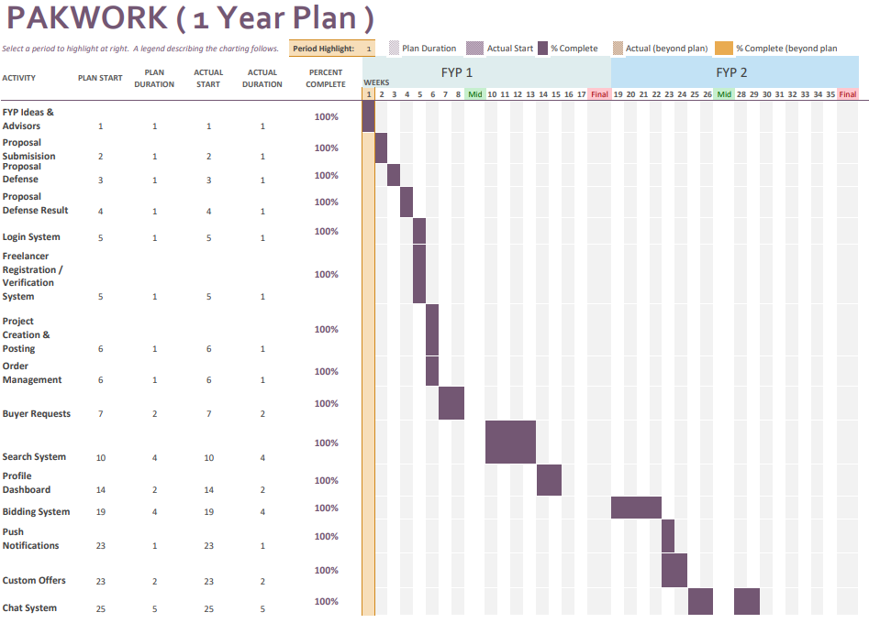

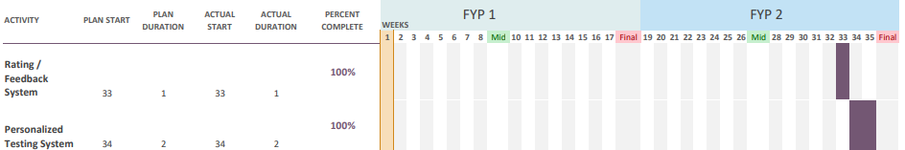

# 12. Work Breakdown Structure

**WBS & Gantt Chart (FYP 1) (Fall)**

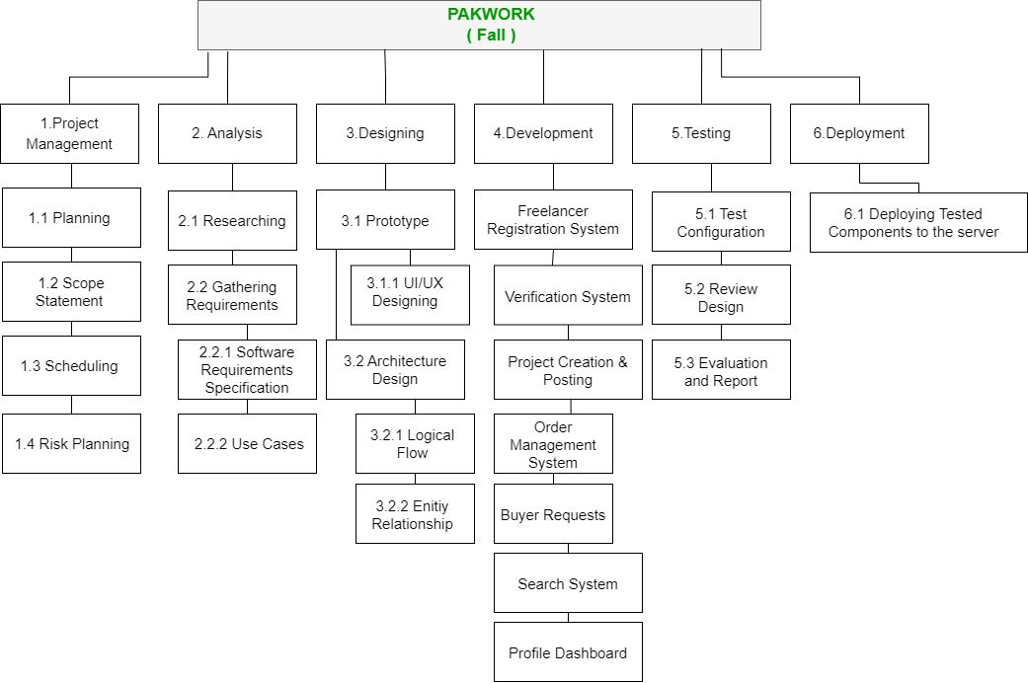

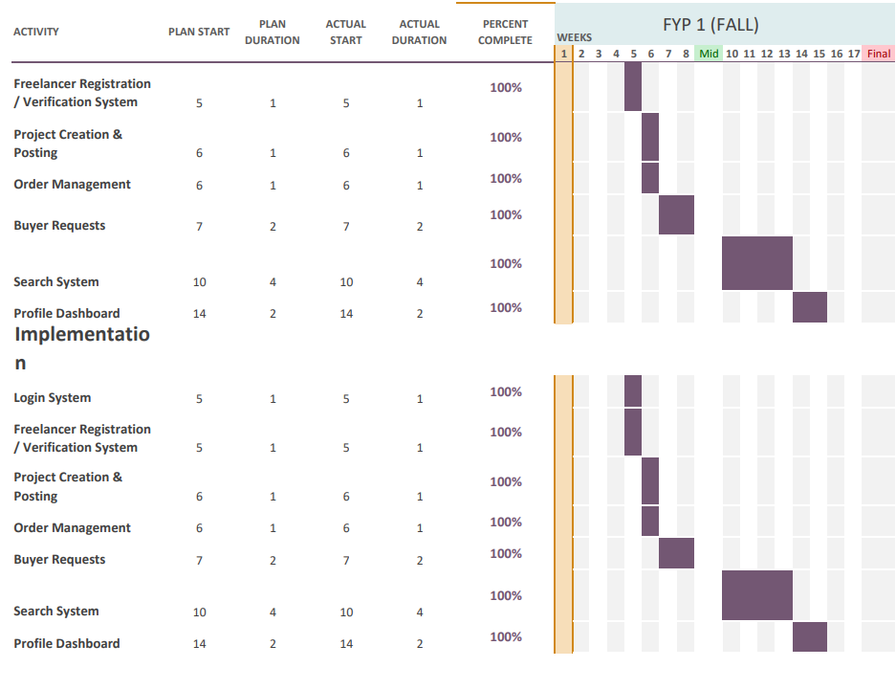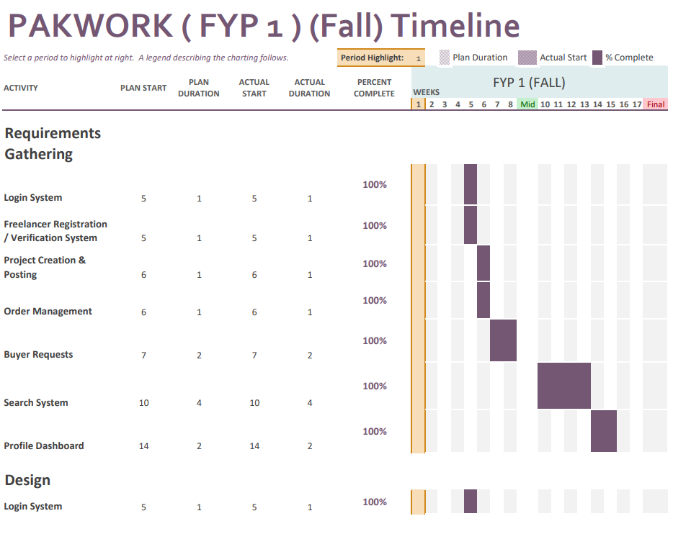

# 

# 

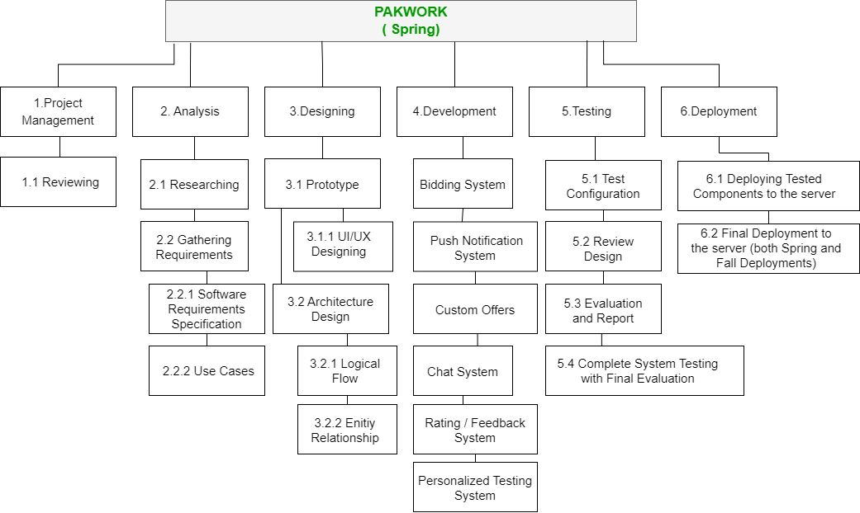**WBS & Gantt Chart (FYP 2) (Spring)**

# 

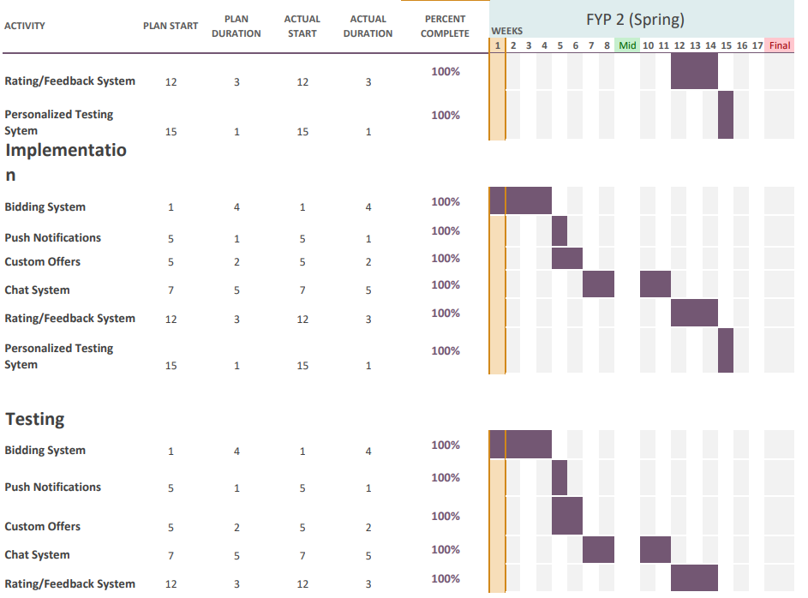

# 

# 13. References

* Daniel Ruby “20+ Freelance Statistics Including All Facts & Data (2022)” DemandSage, August 13th 2022, <https://www.demandsage.com/freelance-statistics/>
* TechAbu “Top 10 Countries with The Most Freelancers 2022” TechAbu, June 12th 2022, <https://techabu.co/freelancing/top-10-countries-with-most-> freelancers

# Software Requirement Specification